**Temporal Dynamics of the Tama Soil Series: A Mandate for Reevaluation of the Central Series Concept**

Iowa State University

AGRON 575

15 Dec 2018

Meyer P. Bohn

Abstract

The Tama soil series is a benchmark Mollisol covering over 1.1 million acres of loess-mantled uplands of the North Central Lowlands. As the unofficial state soil of Iowa, the Tama series has a history of exceptional agricultural productivity and also holds a vital position in soil taxonomic characterization. However, highly erodible Tama soils have frequently been documented having experienced accelerated erosion on a majority of acres. Anthropogenic soil change is an undeniable reality and clearly has an impact on soil transformation over decades. In this study, I attempted to determine if soil properties have changed over time for Tama characterization pedons, i.e., the data we base our central soil series concept on. I also tested if soil texture is a dynamic property rather than a stable property. The data were split into two populations, those sampled before and after 1976. I compared A horizon thickness and depth distributions to 200 cm for soil organic carbon (SOC), clay content, and pH. Welch’s t-test confirmed that pedons sampled post-1976 have significantly thinner A horizons (p < 0.001). One-third of these pedons were moderately eroded. Median SOC was lower in post-1976 pedons at all depths. Median pH was lower at the surface in post-1976 pedons, but higher throughout the subsoil. Peak median clay content was higher near the surface in post-1976 pedons. Three depth classes from 0 to 50 cm had average median clay contents > 27%, indicating a change in characterization texture. Severe disparities in Tama pedon properties over human time-scales mandate that Pedologists reevaluate our characterization methods to account for dynamic anthropogenic soil change.

Table of Contents

Contents

Abstract i

Table of Contents ii

Introduction 1

Materials and Methods 4

Results and Discussion 5

Conclusions 10

References 12

Introduction

One hundred fourteen years ago, the Tama County soil survey was the third survey completed and published in the state of Iowa. Although the Tama series (fine-silty, mixed superactive, mesic, Typic Argiudolls) would not be established until 1917 in Black Hawk County, Iowa, it is likely that the Miami silt loam of the time encompassed many acres of the Tama series (Soil Survey Staff, 2018a). In a description of workability of the Miami soil, Ely et al. (1904, pg. 778) mentioned,

“… fineness of the particles gives the soil a fair moisture-retaining capacity, but without the stickiness of clay… This same quality, however, permits easy washing, and the steep hillsides are rapidly eroded if left exposed.”

The soil survey noted soil change and transformation governed by the hands of human activity. This change observed occurred during a short period of time in their lives. Yet, this period was a blip in the soil formation timeline since the deposition of Peoria loess about 14,000 years ago (Ruhe, 1969).

The pedogenic power of the Holocene would give rise to the Tama series, an extremely extensive and vital land resource and thus a “benchmark soil.” Benchmark soils also have a large amount of data and hold a key position in soil taxonomy. There are currently over 1.1 million acres of Tama soils mapped; eighty-five percent of these acres are in Iowa (Soil Survey Staff, 2018a). As the “unofficial state soil of Iowa” the Tama series has had a long history of exceptional agricultural productivity. Most notably, level slopes of the Tama bolstered a perfect corn suitability rating for Iowa (100) (Fenton et al., 1971). However, as the Tama County soil survey of 1904 also observed, erosion on steeper slopes has had a devastating effect on Tama soils. As of 2012, Tama soils with slopes from 5 to 18% had 75 to 100% of acres eroded (Fenton, 2012).

Following the first soil survey in Tama County, fast forward 38 years to Jenny’s (1941) five state-factors of soil formation, often the first equation one learns in an introductory soils course. Although unsolvable without empirical foundation, Jenny’s “five soil-forming factors” have served as an excellent tool for teaching, learning, and understanding the complexities of soil formation. Implicit in the biological soil forming factor was the influence of human activities. However, humans were not called to attention until 20 years later when Cline (1961) remarked, “… man remakes the soil to suit his needs… for it magnifies man and his activities as factors of soil formation and demands recognition of his work in our model and in our system of classification.” Man, as an additional state-factor, soon was postulated and incorporated into other models of soil formation (Bidwell and Hole, 1965; Yaalon and Yaron, 1966). Since then, human activities have been found to accelerate soil-forming processes so much that new soils are forming in a matter of decades, whereas the temporal scale for natural soil formation was on the order of hundreds and thousands of years (Richter and Markewitz, 2001; Yaalon, 1983).

Nonetheless, the subject of anthropogenic soil transformation has continued to challenge soil scientists because as Richter and Yaalon (2012) argue, human influences challenge us to think beyond natural soil formation and force us to expand our scientific discourse to social and cultural disciplines. For these reasons, and many unnamed others, it may be why soils are often misconceived as static entities. Furthermore, our inability to transform the cultural perspective of soils may be why the culture of the conventional tillage has stifled adoption of reduced tillage practices. Therefore, the processes of human accelerated erosion have gone largely unchanged.

In 1982, the Corn Belt lost 374.5 million tons of soil annually on highly erodible cropland. Thirty years later, annual soil erosion rates had decreased, but were still an astounding 134.5 million tons (NRCS, 2007). The degradative impacts of accelerated erosion on Mollisols in the United States and Canada are well documented (Cihacek and Swan, 1994; De Alba et al., 2004; Papiernik et al., 2005; Malo et al., 2005). Furthermore, accelerated erosion on Iowan soils specifically has been frequently studied (Fenton et al., 2005; Kazemi et al., 1990; Richardson and Riecken, 1977; Veenstra and Burras, 2015). These impacts have changed Iowan Mollisols like the Tama series in many ways. But, one of the most profound ways is the truncation of the topsoil (master A horizon) to the extent that it no longer meets the Mollisol taxonomic requirements (Fenton, 2012; Veenstra and Burras, 2012). It would be foolish to say that this change is profound because former Mollisols no longer have the required thickness or dark color to have a true mollic epipedon. Rather, the change in soil properties is an implicit change in soil function (Tugel et al., 2005). That is of the utmost concern.

To parallel the erosion observations of the 1904 Tama County soil survey, presently, the National Cooperative Soil Survey (NCSS) has identified soil properties that change over the human time-scale as “dynamic soil properties.” These include soil organic carbon (SOC), bulk density, pH, salinity, and aggregate stability as a few examples. Tugel et al. (2005) argued that these properties not only have greater temporal variability, but also greater spatial variability as opposed to more stable properties such as texture and mineralogy (Wilding et al., 1994). Soil texture specifically has been defined as a persistent soil property, i.e. stable for over 100 years (Richter, 2007).

Frequently documented instances of soil change, especially for eroded Mollisols, begs the question: Have our standards for characterization and classification at lowest level of taxonomy, the soil series, also changed? In this study, I attempted to elucidate potential disparities in NCSS characterization Tama pedon properties as differentiated by time, i.e. sampled before and after 1976. Furthermore, I challenged the concept that soil texture is a temporally stable property by comparing clay fractions between the two “time-separated” populations of pedons. These research questions stand on the assumption that characterization sampling is performed via the *relevé* method, a subjective method to select central representative pedons. By this assumption, I remove bias associated with soil spatial variability and isolate temporal variability, the central focus of the study.

**Hypotheses test 1:**

Ho: The A horizon thickness in pedons sampled before 1976 does not differ from those sampled after 1976.

Ha: Pedons sampled before 1976 have thicker A horizons than pedons sampled after 1976.

**Hypotheses test 2:**

Ho: Distribution by depth of SOC, pH, and clay content for pedons sampled before 1976 does not differ from those sampled after 1976.

Ha: Distribution by depth of SOC, pH, and clay content for pedons sampled before 1976 is different from those sampled after 1976.

**Hypotheses test 3:**

Ho: Soil texture is a persistent property that does not change during the human time-scale.

Ha: Soil texture is a dynamic property that changes during the human time-scale.

Materials and Methods

All data was processed in R version 3.5.1 (R Core Team, 2016) and RStudio version 1.1.423 (RStudio Team, 2018). The Algorithms for Quantitative Pedology or ‘aqp’ package developed by Beaudette et al. (2013) was used in RStudio to access and manipulate the NCSS soil characterization database (NCSS, 2018). There were 75 Tama pedons with A horizon information, 18 of which were sampled prior to 1976, but not before 1960. The remaining pedons were sampled as late as 1988. The A horizon thickness was calculated for the two populations and statistically compared with the Welch two sample t-test with unequal variances (α = 0.05).

There were 105 pedons analyzed for chemical and physical properties by depth distribution, 21 of which were sampled between 1960 and 1976. Distributions of SOC, clay content (%), and pH1:1 by depth were plotted at the median, 25th, and 75th percentiles to 200 cm for comparison between time populations. To account for incomplete portions of the dataset, a percent contributing fraction per 10 cm was calculated to display the proportion of data from each population included in the distribution. To simplify comparisons and garner topics of discussion, the median depth values for each soil property were subsequently averaged for six depth classes (0 to 10 cm, 10 to 20 cm, 30 to 50 cm, 50 to 100 cm, 100 to 150 cm, 150 to 200 cm).

Results and Discussion

The A horizon thickness of pedons populations sampled before 1976 were statistically significantly thicker (p < 0.001) than post-1976 pedons. The assumption of normality was broken for post-1976 pedon distribution considering the data were skewed right. Nonetheless, Welch (1947) maintains that the statistical test remains robust with greater amounts of observations. Outliers in the pre-1976 population were included in the statistical test because although they are statistical outliers, they are representative of reality and the *relevé* concept. The summary statistics and boxplot are given in table 1 and figure 1 respectively.

Upon further investigation, 19 pedons sampled from 1984 to 1987 in Iowa had A horizon thicknesses that ranged from 18 cm to 10 cm. Soil survey standards maintain that soils with A horizon thicknesses from 8 to 18 cm qualify as moderately eroded and should be mapped as separate phases (Soil Survey Staff, 1993). If one-third of the representative Tama pedons are moderately eroded, how representative are they? I would argue that this phenomenon symbolizes a major soil function state change and therefore A horizon thickness is a dynamic soil quality (Seybold, 1999). According to the Iowa Daily Erosion Project (DEP), soil loss on highly erodible land has translated to reduction of 29 bushels per acre in corn yields (from DEP in Smith, 2017). This evidence supports the idea that the Tama soil’s capacity to function has diminished and the centralized concept of the Tama series no longer applies.

|  |  |  |  |  |  |  |  |  |  |
| --- | --- | --- | --- | --- | --- | --- | --- | --- | --- |
| Table 1. Summary statistics of A horizon thickness for Tama pedons. | | | | | | | | | |
| Class | **n** | **mean** | **st. dev.** | **median** | **min** | **max** | **range** | **skew** | **kurtosis** |
| pre-1976 | 18 | 44.4 | 11.34 | 43 | 30.4 | 71.1 | 40.7 | 0.98 | 0.01 |
| post-1976 | 57 | 30.36 | 14.13 | 30 | 10 | 61 | 51 | 0.42 | -1.02 |

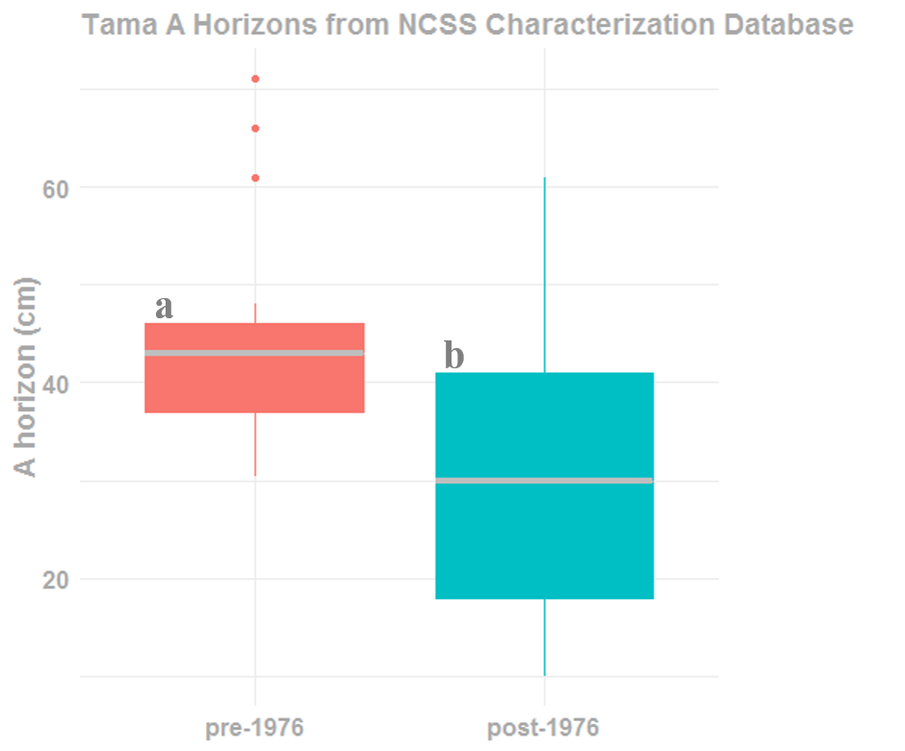

Figure 1.

The latter focus of this study highlights the differences in pedon by time populations for depth distribution of SOC (oc), pH (ph_h2o), and percent clay content (clay) (Figs. 2-5). First of all, overall trends indicate that the median SOC value for post-1976 pedons is lower than pre-1976 pedons. The obvious separation occurs where the 25th percentile from the pre-1976 pedons does not even overlap with the 75th percentile from the post-1976 pedons (Fig. 2).

Secondly, clay content was greater near the surface of the post-1976 Tama solum where the median peaks at about 32% near 30 cm. The clay increase in the argillic horizons of the pre-1976 pedons occurs much lower in the profile, peaking at roughly 28% near 50 cm. Assuming clay content has increased due to erosion and truncation of the solum, thus incorporating illuvial clay higher in the surface, this has serious implications for soil function and is in fact another indicator of dynamic soil change. Frye et al. (1982) showed that increased clay content due to erosion reduces available water content (AWC). Reduced AWC coupled with lower SOC translates to lower fertility status, ergo lower yields, and reduced functioning capacity.

Moreover, the data supports my hypothesis that soil texture is changing over human-time-scales. For depth classes 0 to 10 cm, 10 to 20 cm, and 20 to 30 cm, clay content in the post-1976 pedons was 3.3, 3.4, and 4.6% higher than pre-1976 pedons respectively. Considering the break between silt loam and silty clay loam is at 27% clay, these clay contents indicate a different texture class for the top three depth classes (Fig. 4). The particle size control section adjusts for pedogenic influences on texture differentiation, namely soils with argillic horizons like the Tama series. In general, the Tama particle size control section is from 25 to 100 cm (Soil Survey Staff, 2014). Yet still, changes are apparent considering the particle control size section average median clay content from 0 to 200 cm was 1.4% higher in post-1976 pedons (31%).

Lastly, pH depth distribution values showed contrasting trends between the surface and subsoil. Post-1976 pedons had a slightly higher average median pH from 0 to 10 cm (Fig. 4). This may be attributed to the drastic changes in pH that can occur due to inorganic fertilizer applications, undoubtedly a difficult variable to control for when sampling representative pedons (Bouman et al., 1995). Overall, post-1976 pedons had higher pH values through the depth of 200 cm (Figs. 2 & 4). Changes in pH associated with dissolution of organic matter also contribute to the dissolution of carbonates and subsequent deeper translocation/precipitation which may buffer the system at higher pH levels lower in the profile depending on CO2 partial pressure (Buyanovksy and Wagner, 1983).

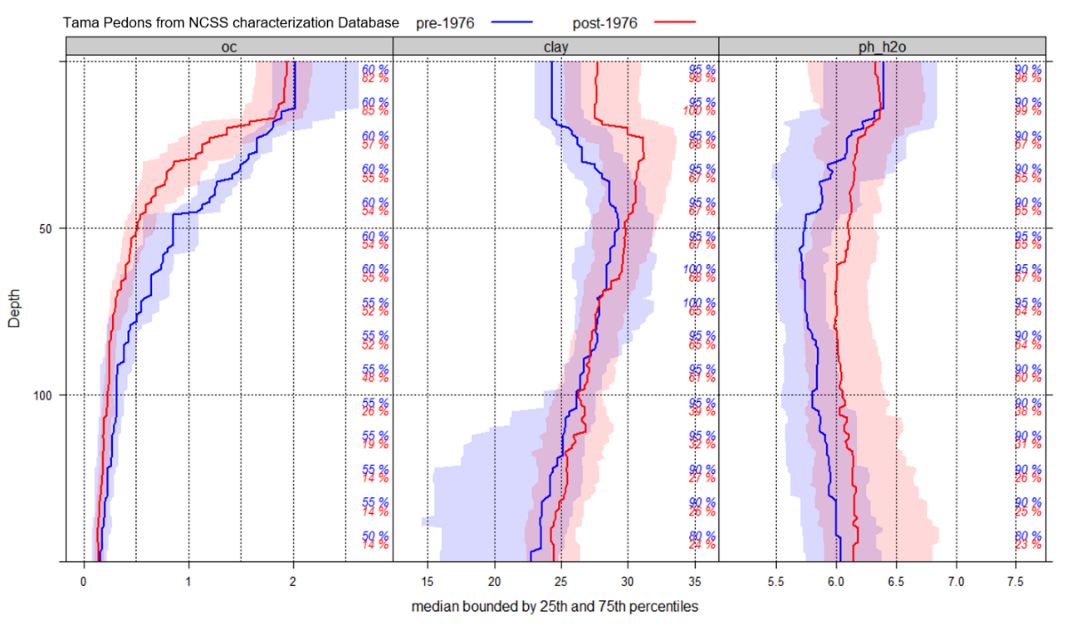

Figure 2.

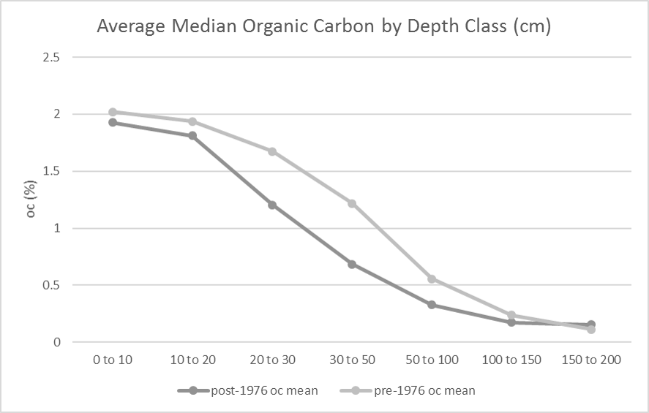

Figure 3.

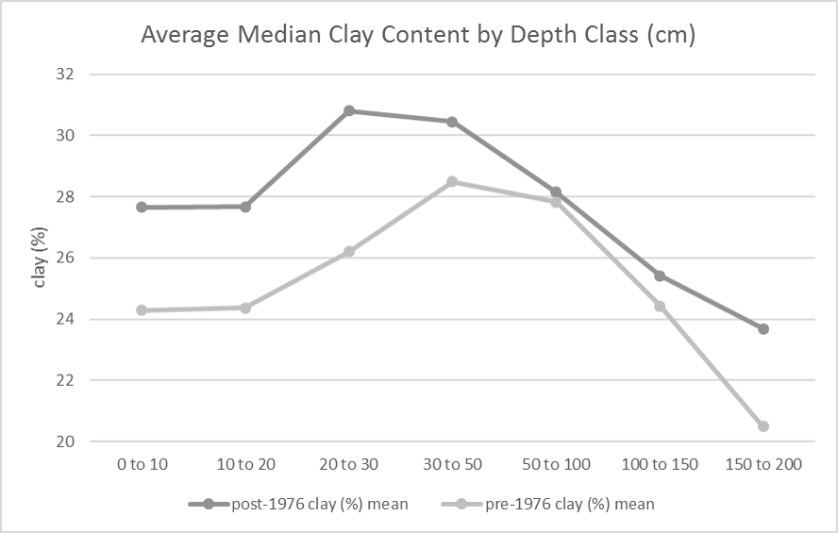

Figure 4.

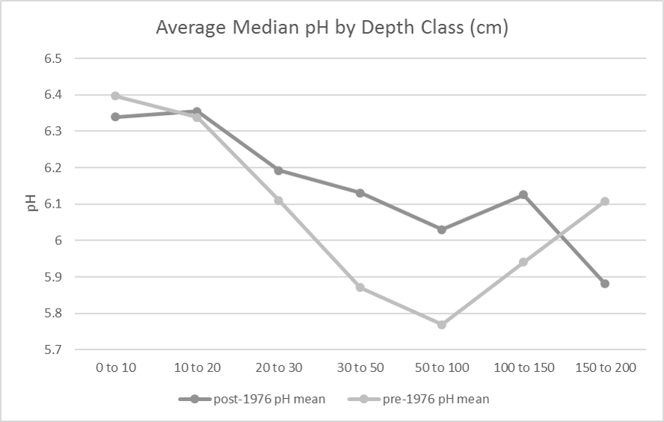

Figure 5.

Conclusions

In this study, I sought to elucidate differences in A horizon thickness, SOC, clay content, and pH for Tama characterization pedons sampled before and after 1976. Soil pH is perhaps the most capricious and dynamic soil property, likely governed by seasonal human activities and dependent on synthetic fertilizer applications. Regardless, overall higher pH values in post-1976 pedons indicate a temporally contrasting base cation transformation regime. The evidence shows that A horizons from Tama pedons sampled after 1976 are significantly thinner than those sampled from 1960 to 1976. Moreover, one-third of post-1976 pedons would classify as moderately eroded and are clear indicators that representative pedon sampling has captured the dramatic state change of soil function in highly erodible loessial soils of the Corn Belt.

Additionally, SOC median depth values from post-1976 pedons are lower than those sampled prior to 1976. Reduction of the primary resource pool that serves as the foundation of inherent fertility in Mollisols is another viable indicator of degradative alteration in soil function. Concomitant increases in clay content near the surface exacerbate the negative impact on productivity induced by erosion and truncation of the solum. Furthermore, average median clay content in post-1976 pedons for depth classes to 50 cm classified as a different texture classes compared to pre-1976 pedons. Thus, the evidence verifies that soil texture is a dynamic property as it pertains to the Tama soil series. Based on these findings, I conclude that the scientific discipline of Pedology as a whole should take serious measures to reevaluate our characterization of the central concept that is the soil series. It is our duty to society to account for the undeniable anthropogenic influences that dominate soil transformation and functioning capacity.

References

Bidwell, O.W., and F.D. Hole. 1965. Man as a factor in soil formation. Soil Sci. 99:65–72. doi:10.1097/00010694-196501000-00011.

Bouman, O.T., D. Curtin, C.A. Campbell, V.O. Biederbeck, and H. Ukrainetz. 1995. Soil acidification from long-term use of anhydrous ammonia and urea. Soil Sci. Soc. Am. J. 59:1488–1494. doi:10.2136/sssaj1995.03615995005900050039x.

Buyanovsky, G.A., and G.H. Wagner. 1983. Annual cycles of carbon dioxide level in soil air. Soil Sci. Soc. Am. J. 47:1139–1145. doi:10.2136/sssaj1983.03615995004700060016x.

Cihacek, L.J., and J.B. Swan. 1994. Effects of erosion on soil chemical properties in the north central region of the United States. Journal of Soil and Water Conservation 49(3): 259–265. http://www.jswconline.org/content/49/3/259.short. Accessed 3 Jan 2017.

Cline, M.G. 1961. The changing model of soil. Soil Sci. Soc. Am. Proc. 25:442–446. doi:10.2136/sssaj1961.03615995002500060009x

D.E. Beaudette, P. Roudier, A.T. O’Geen. 2013. Algorithms for quantitative pedology: A toolkit for soil scientists, Computers & Geosciences. 52: 258–268. http://dx.doi.org/10.1016/j.cageo.2012.10.020. Accessed 11 Dec 2018.

De Alba, S., M. Lindstrom, T.E. Schumacher, and D.D. Malo. 2004. Soil landscape evolution due to soil redistribution by tillage: a new conceptual model of soil catena evolution in agricultural landscapes. Catena 58(1): 77–100. doi: 10.1016/j.catena.2003.12.004.

Ely, C.W., G.N. Coffey, and A.M. Griffen. 1904. Soil survey of Tama County, Iowa. United States Department of Agriculture. Bureau of Chemistry and Soils. Washington, DC.

Fenton, T. E., Kazemi M, Lauterbach-Barrett M A. 2005. Erosional impact on organic matter content and productivity of selected Iowa soils. Soil Tillage Res. 81: 163-171.

Fenton, T.E., E.R. Duncan, W.D. Shrader, and L.C. Shrader. 1971. Productivity levels of some Iowa soils. Special Report No. 66. Iowa State University. Ames, Iowa.

Fenton, T.E. 2012. The impact of erosion on the classification of Mollisols in Iowa. Canadian Journal of Soil Science 92(3): 413–418. doi: 10.4141/cjss2010-042.

Frye, W.W., S.A. Ebelhar, L.W. Murdock, and R.L. Blevins. 1982. Soil Erosion Effects on Properties and Productivity of Two Kentucky Soils. Soil Science Society of America Journal 46(5): 1051. doi: 10.2136/sssaj1982.03615995004600050033x.

Kazemi, M., Dunenil, L. C. and Fenton, T. E. 1990. Effects of accelerated erosion on corn yields of loess-derived and till-derived soils in Iowa. Final report for Soil Conservation Service, Agreement No. 68-6114-0-08, Des Moines, IA.

Malo, D., T. Schumacher, and J. Doolittle. 2005. Long-term cultivation impacts on selected soil properties in the northern Great Plains. Soil and Tillage Research 81(2): 277–291. doi: 10.1016/j.still.2004.09.015.

NCSS. 2018. National Cooperative Soil Characterization Database. Available online. Accessed 6 Dec 2018.

NRCS. 2007 National Resource Inventory. NRCS-USDA. Available online. 11 Dec 2018.

Papiernik, S.K., M.J. Lindstrom, J.A. Schumacher, A. Farenhorst, and et al. 2005. Variation in soil properties and crop yield across an eroded prairie landscape. Journal of Soil and Water Conservation; Ankeny 60(6): 388–395. https://search.proquest.com/docview/220971179/abstract/F93212C80B5F4AC9PQ/1. Accessed 20 Nov. 2017.

R Core Team. 2018. R: A language and environment for statistical computing. R version 3.5.1 Foundation for Statistical Computing, Vienna, Austria. https://www.R-project.org/. Accessed 11 Dec 2018.

Richardson J L, Riecken F F. 1977. Differences in exchangeable aluminum and soil acidity in loess soils in Iowa. Soil Sci. Soc. Am. Proc. 41: 588-593

Richter, D. deB, and D.H. Yaalon. 2012. “The Changing Model of Soil” Revisited. Soil Science Society of America Journal 76(3): 766. doi: 10.2136/sssaj2011.0407.

Richter, D. deB. 2007. Humanity’s transformation of earth’s soil: Pedology’s new frontier. Soil Science 172(12): 957–967. doi: [10.1097/ss.0b013e3181586bb7](https://doi.org/10.1097/ss.0b013e3181586bb7).

RStudio Team. 2018. RStudio: Integrated Development for R. Version 1.1.423. RStudio, Inc., Boston, MA. http://www.rstudio.com.

Ruhe, R.V. 1969. Quaternary landscapes in Iowa. Iowa State University Press, Ames, Iowa.

Seybold, C.A., J.E. Herrick, and J.J. Brejda. 1999. Soil Resilience:  A fundamental component of soil quality. Soil Science 164(4): 224–234.

Smith, Rick. Iowa’s “Black Gold” Is Washing Away. 2017. Iowa Starting Line. <https://iowastartingline.com/2017/08/14/iowas-black-gold-washing-away/> Accessed 12 Dec 2018.

Soil Survey Staff. 2018a. NRCS-USDA. Official Soil Series Descriptions. Available online. Accessed 10 Dec 2018.

Soil Survey Staff. 2018b. NRCS-USDA. Web Soil Survey. Available online. https://websoilsurvey.sc.egov.usda.gov/. Accessed 10 Dec 2018.

Soil Survey Staff. 2014. Keys to soil taxonomy. 12th ed. USDA-NRCS. U.S. Gov. Print. Office, Washington, DC.

Soil Survey Staff. 1993. Soil survey manual US Department of Agriculture. Handbook No. 18. Washington, DC.

Tugel, A.J., J.E. Herrick, J.R. Brown, M.J. Mausbach, and et al. 2005. Soil Change, Soil Survey, and Natural Resources Decision Making: A Blueprint for Action. Soil Science Society of America Journal 69(3): 738–747. http://search.proquest.com/docview/216076991/abstract. Accessed 29 Jan 2016.

Veenstra, J.J., and C. Lee Burras. 2015. Soil Profile Transformation after 50 Years of Agricultural Land Use. Soil Science Society of America Journal 79(4): 1154. doi: 10.2136/sssaj2015.01.0027.

Veenstra, J.J. and C.L. Burras. 2012. Effects of agriculture on the classification of Black Soils in the Midwestern United Sates. Can. J. Soil Sci. 92:403-411.

Welch, B. L. 1947. The generalization of student's problem when several different population variances are involved. Biometrika. 34 (1–2): 28–35. doi:10.1093/biomet/34.1-2.28. MR 0019277.

Wilding, L.P., J. Bouma, and D.W. Goss. 1994. Impact of spatial variability on interpretive modeling. P. 61-75. *In* R.B. Bryant and R.W. Arnold (eds.) Quantitative modeling of soil forming processes. SSA Spec. Publ. 39. ASA, CSSA, and SSSA, Madison, WI.

Yaalon, D.H. 1983. Climate, time and soil development. In: Wilding, L.P., Smeck, N.E., and G. F. Hall, (eds.), Pedogenesis and soil taxonomy: 1 Concepts and interactions. Elsevier. Amsterdam. p. 233–251.

Yaalon, D.H., and B. Yaron. 1966. Framework for man-made soil changes—An outline of metapedogenesis. Soil Sci. 102:272–278. doi:10.1097/00010694-196610000-00010.